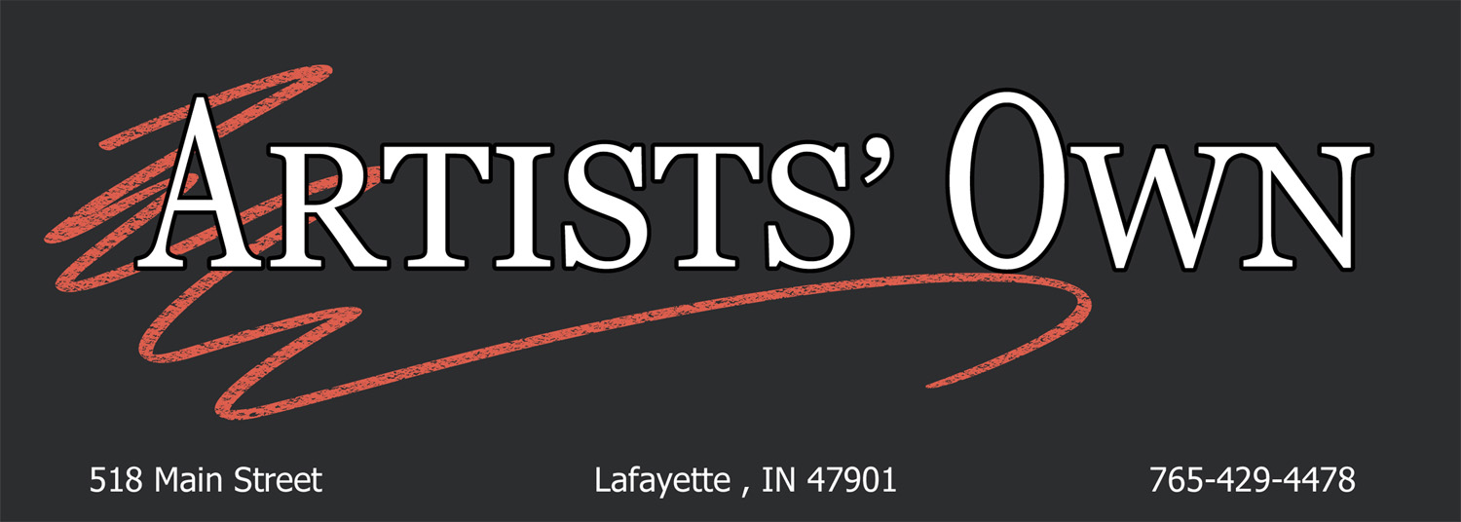
Consignment Application
To apply: Print and complete the Consignment Application Form below. E-mail the form along with the additional information/images listed below to: application@artists-own.com

Include in e-mail at time of application:
(1) Brief artist’s statement (100 words or less)
(2) Resume
(3) Type of Media
(4) Description of artwork – materials used and techniques (200 words or less)
(5) 5-7 images of work that is no more than 2 years old and is in saleable finished
condition. Images (use 300 dpi) should be labeled as follows

Image #.Artist’sname.title.media.size.retailprice.
(Example: #1.VanGogh.StarryNight.Oil,8x10.$10)

(6) An image of yourself; can be a photo of you creating your artwork
(7) Additional information you’d like us to know

CONSIGNMENT APPLICATION FORM

Date: ____________________________________________________

Name: _______________________________________________
Street Address: ____________________________________________
City: _____________________________________________________
State: ___________________ Zip Code: ________________________
Home Phone: ______________________________________________
Cell Phone: ________________________________________________
Email: ____________________________________________________
Website: __________________________________________________

How did you hear about Artists’ Own? ___________________________________

Member’s name if referred to AO _________________________________

A committee member will keep you informed of the status of your application. If approved, a meeting will be arranged to sign our contract and bring in artwork. At this time, you will need to provide your Social Security # for sales purposes. Someone from our Marketing Committee will contact you regarding promotion of you and your artwork during your contract period.

